NAME OF PROJECT

PREDICTION OF LOAN APPLICATION STATUS

| |
| |
| |
| |
| |

SUBMITTED BY

PANKAJ ADHIKARI

1. INTRODUCTION
This is a type of Project which help us determine and predict the Loan Application Status of the Customer based on their personal, Income and other socioeconomic factors. This type of data are widely used in Financial sector such as Banks, Insurance Company to provide Loan for the eligible customers. This data has the details of customer who had applied for the loan which provide an insight on whether the loan is sanctioned to the customer. Here ‘Y’ means loan is approved and ‘N’ means loan has been rejected.

2. PROBLEM DEFINITION
The main problem here is there is no definitive mechanism to determine if the Loan has been approved. Hence we have the data of previous Loan Data along with the necessary variables to predict the future outcome. To Predict the data we first have to analyse the data set that has been provided as per the techniques below.

3. DATA ANALYSIS
Here we analyse the data set bring it to proper format so that the dataset can be used in predicting the Target for future loans.

DATA PRE-PROCESSING
Loading of Libraries
First we import the imporant libraries as below

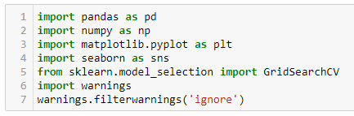
Loading of Dataset in DataFrame

After uploading the data as DataFrame (df) we visualise and clean the data.
We have 614 Rows and 13 Columns

Output
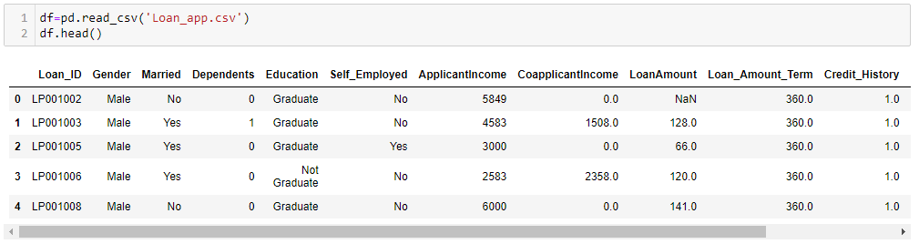
Checking for Missing or Null Values
Here we find a lot of missing data using df.isnull().sum().sort_values(ascending=False)

Output
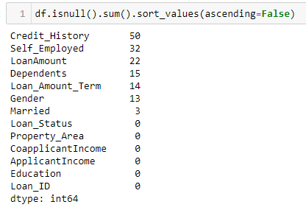
Filling of Missing Data
Here we see a lot of missing data in list of descending order. Hence we need to replace the missing value as per the appropriate value in the respective columns as shown below and check the missing values.
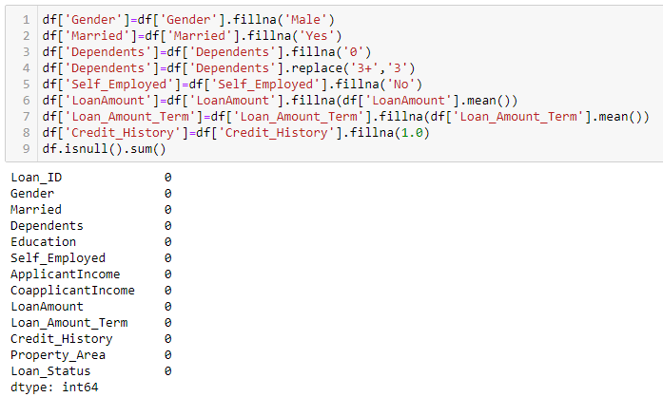
- In the above Output we see that Columns ‘LoanAmount’ and ‘Loan_Amount_Term’ is filled with mean value of the column whereas the rest of the column mode of the value has been used
Important Attributes
Here we check the important attributes of Columns such as mean, count, Standard Deviation, 25-50-75 percentile, minumum , maximum values.

df.describe()
plt.figure(figsize=(8,5))
sns.heatmap(df.describe(),annot=True,linewidth=0.5,linecolor='green',fmt='0.1f')

Output
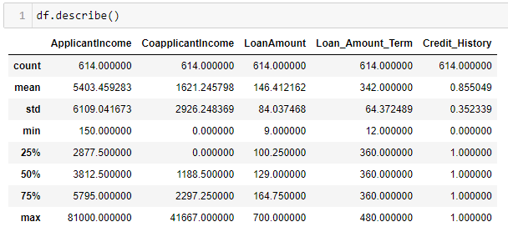
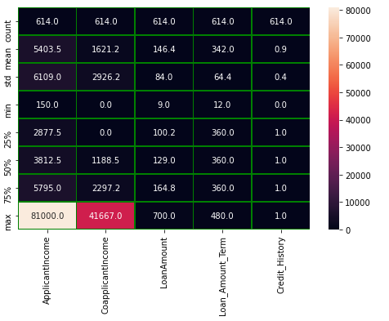
Fig : Heat map of df.describe()

Fig : Figure of df.describe()

In the above figure we see that mean of the data exceeds 50 percentile in Columns ‘ApplicantIncome’ , ‘CoapplicantIncome’ and ‘LoanAmount’ signifying data to be positive skewed. Whereas 50percentile exceeds in Columns ‘Loan_Amount_Term’ signfying data to be negative skewed

Skewness of Columns
Skewness of Columns in Descending Order
skew=df.skew().sort_values(ascending=False)
Output
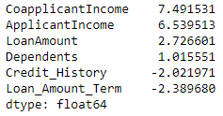
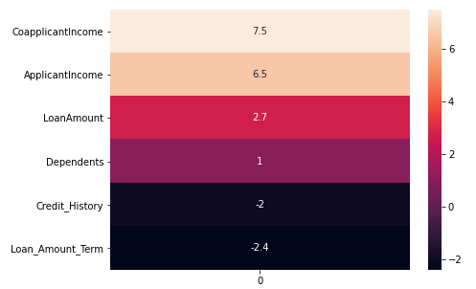
Fig : Heat map of Skewness

Fig : Skewness of Columns in descending order

– In above Figures we see Skewness of Columns in Descending Order along with Heatmap showing Columns ‘ApplicantIncome’ , ‘CoapplicantIncome’ and ‘LoanAmount’ is positive skewed and Columns ‘Loan_Amount_Term’ , ‘Credit_History’ to be negative skewed.

Correlation Heatmap
Output
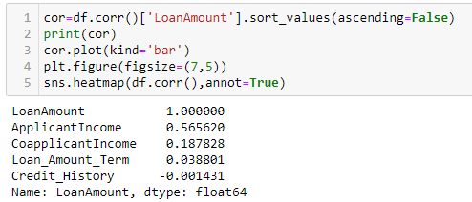
Fig : Correlation of Columns in Descending Order

The above output shows descending order of correlation with respect to Column ‘LoanAmount’
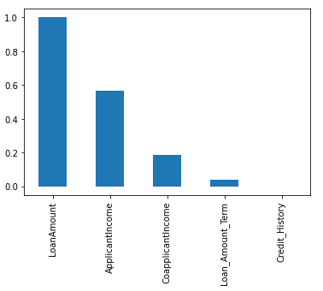
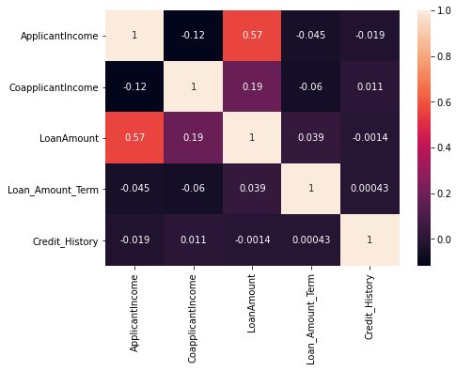
Fig : Correlation Plot in Descending Order

Fig : Correlation Heatmap

The above Figures shows Bar Plot in Descending Order and Heat map of Correlation of Columns. In the Heat map, correltion between ‘ApplicantIncome’ and ‘LoanAmount’ is high. ‘ApplicantIncome’ and ‘CoapplicantIncome’ has very low correlation.

Plots and Graphs
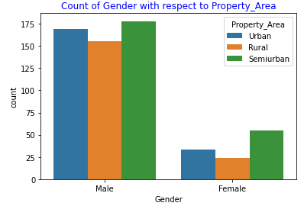
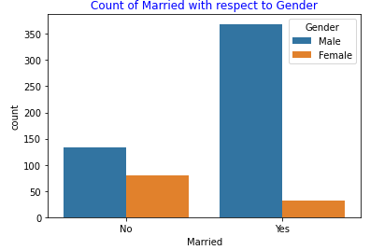

– In above Count Plot of Gender we see that Male have high count in Urban, Rural, Semiurban Property Area. Female Count is very less.
– In above Count Plot of Married we see that count of Married Male are high and Count of Female is Low.

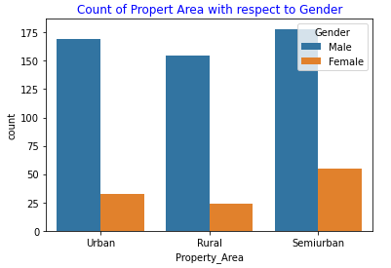
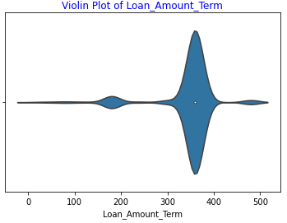

– In the above Count Plot of Property Area we see that ‘Semiurban’ has the Highest count and the ‘Rural’ has the least count with Male Gender in high count in all 3 types of Property_Area.
– The above violin Plot shows shows maximum count of ‘Loan_Amount_Term’ between 300 and 400.

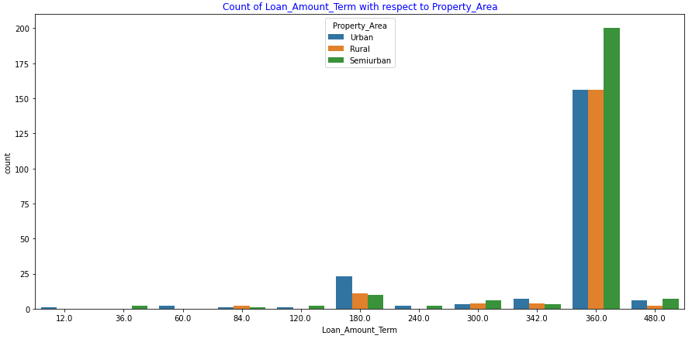
– In the above Count Plot of ‘Loan_Amount_Term’ we see maximum count at 360 with Semiurban being highest among Property_Area.
Fig : Pair Plot Between Columns

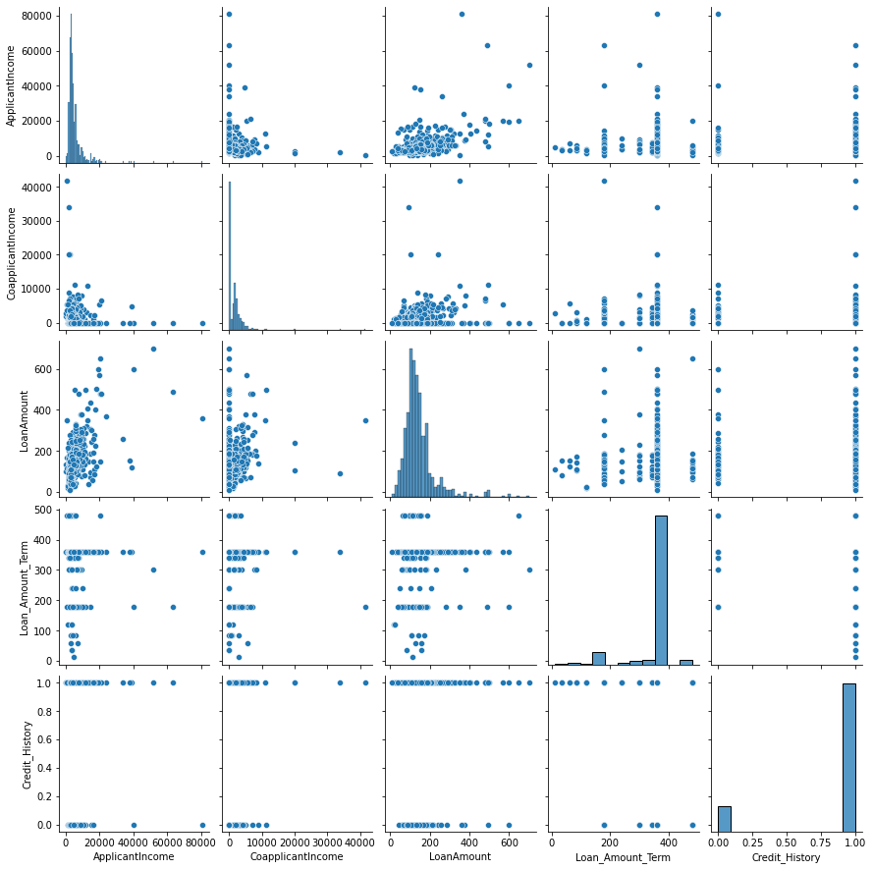
Pair Plot Between Columns

In the above Pair Plot of Columns we can see that most of the datas are clusterred and is positive skewed.
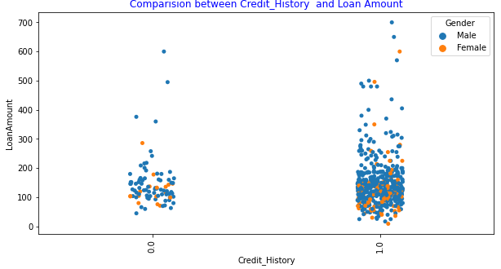

– In the above comparison plot between Credit_History and Loan Amount we see that Credit History of ‘1’ has high density and ‘0’ has low density. Also grouping by gender we see that Male have high density count.
– The Loan Amount is highest at around 700 in Credit_History ‘1’.

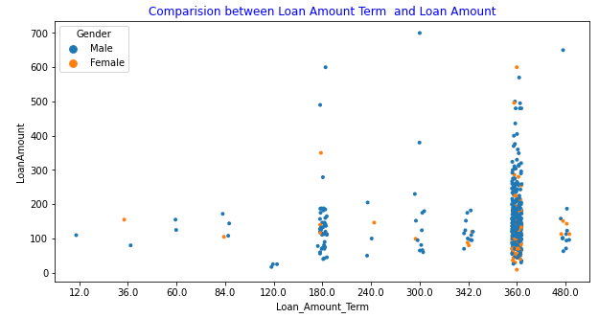

– In the above comparison plot between ‘Loan_Amount_Term’ and ‘Loan Amount’ we see that 360 unit has the highest count.
– Also 300 and 120 ‘Loan_Amount_Term’ have the highest and the lowest ‘Loan Amount’ respectively.

Droppoing of Column Loan_ID
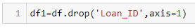
We drop the Column Loan_ID as it has a unique set of values hence it cannt be used in predcition of Target.

Change of Data Type
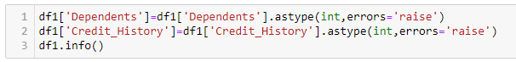
Here we change the Data Type of Columns ‘Dependents’ and ‘Credit_History’ to Interger for better evaluation as it is Object type in the data set which would provide an error.

Label Encoding Columns
Output
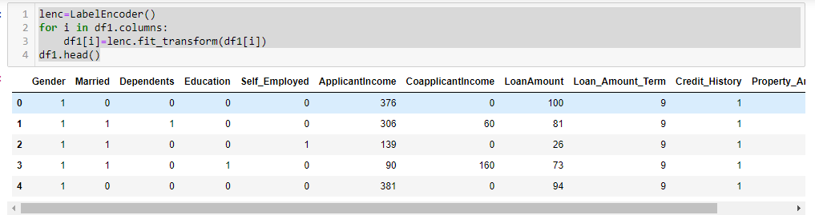
Fig : Label Encoding of Columns

– Here we use Label Encoding to the columns and to convert the string into numerical for better evaluation and precision.

Removing Outliers
Box Plot
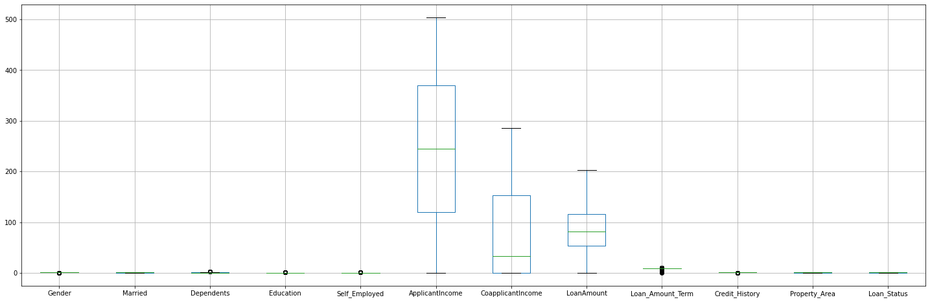
Fig : Box Plot
– In the above Box plot shows that column ‘Loan Amount Term’ have outlier

Output
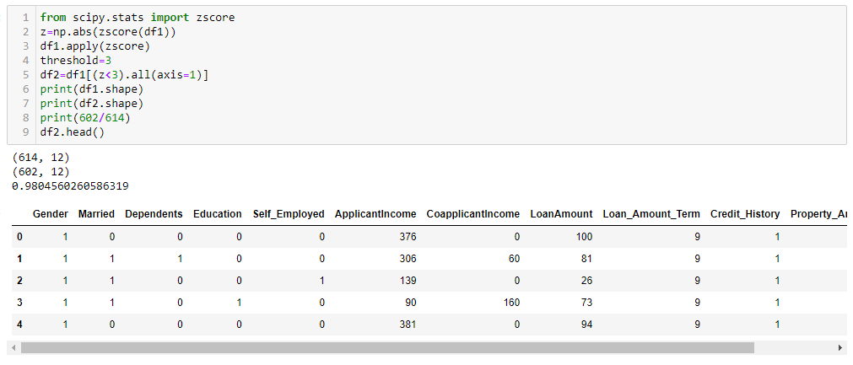
Fig : Removing Outlier by Z-Score

– In the above Output we see that after removal of outliers we have 602 rows and 12 columns retaining 98% of the data.

4. EDA CONCLUDING REMARKS
After analysing and proper evaluation of data we have the correct data format for further processing to prediction

5. PRE-PROCESSING PIPELINE

Defining x and y

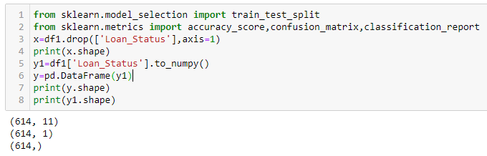
– First we define the data ‘x’ and ‘y’ for prediction the data as Variable and Target. Here ‘x’ is the columns and ‘y’ is the output column.

Train, Test Split
Output
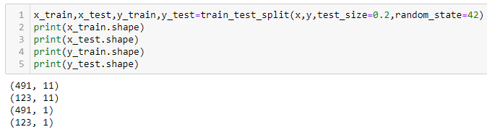
– We use Train, Test, Split to ‘x’ and ‘y’ into x_test, x_train, y_test and y_train.
– This Test Train will be use in Machine Learning Models for prediction the accuracy score.

6. BUILDING MACHINE LEARNING MODELS

Since the Target is Classified as ‘Y’ and ‘N’ we can say that the Output is Classified Type. Hence We use Classification Model to Predict the outcome. The Machine Learning models used in this project is as below along with the output of the Model.

1. Logistic Regression
Grid Search CV
The First step is to find the best parameters that will give us the best accuracy of the model. This parameters are defined in the Output as shown below.
Output
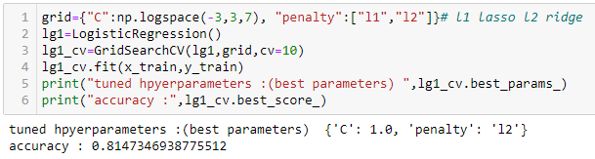
Prediction Model
In the Prediction Model we use the best parameter in the above output.
Output
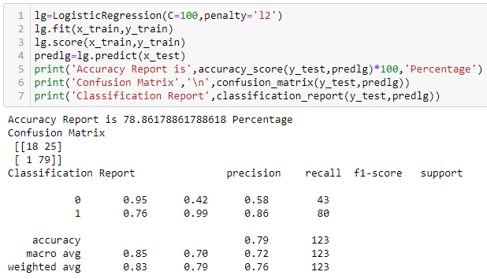
-- In the above output we see that Accuracy Report is 78% and Error is 26
Heatmap of Confusion Matrix
Output

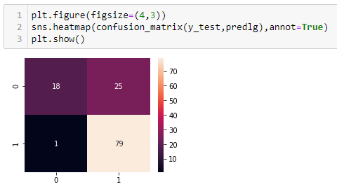

2. Decision Tree Classifier
Grid Search CV
The best parameters for Decision Tree Classfier is defined in the Output as shown below.
Output
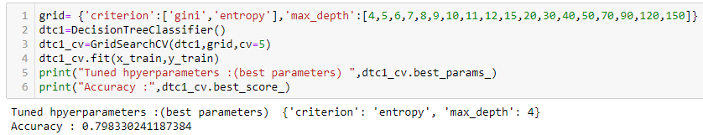
Prediction Model
In the Prediction Model we use the best parameter in the above output.
Output
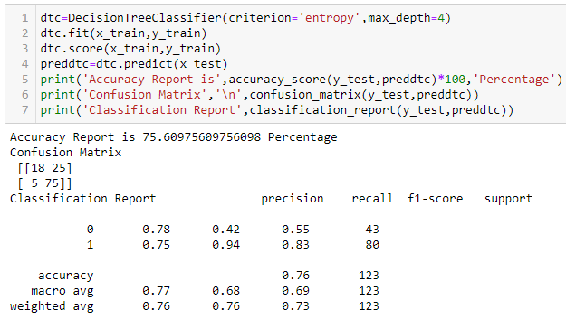
-- In the above output we see that Accuracy Report is 75% and Error is 30
Heatmap of Confusion Matrix
Output
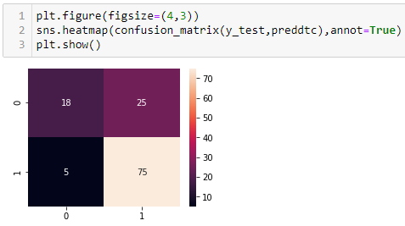

3. Support Vector Classifier
Grid Search CV
The best parameters for Support Vector Classifer is defined in the Output as shown below.
Output
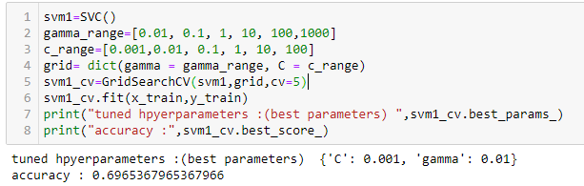
Prediction Model
In the Prediction Model we use the best parameter in the above output.
Output

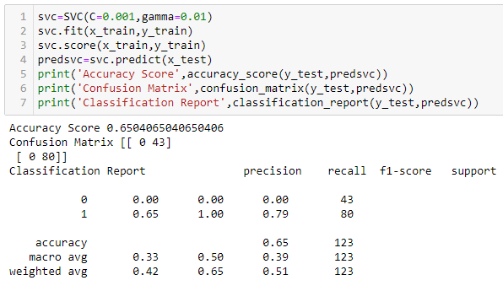
-- In the above output we see that Accuracy Report is 65% and Error is 43
Heatmap of Confusion Matrix
Output
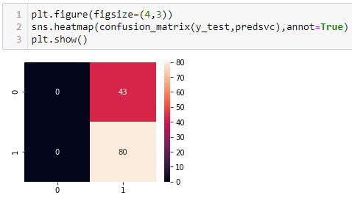

4. K-Neighbors Classifier
Grid Search CV
The best parameters for K-Neighbors Classifer is defined in the Output as shown below.
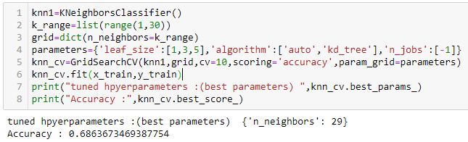
Output

Plotting of n_neighbors with respect to accuracy
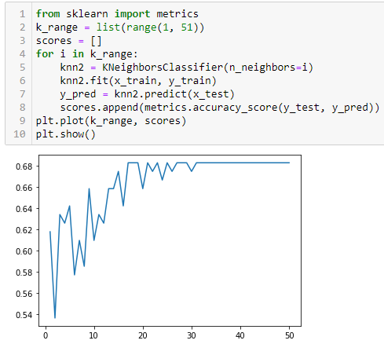
– In the above Plot we can see that at value of n_neighbors around 30 we have constant accuracy of 68%. As per the Grid Search CV the value of n_neighbors is 29.

Prediction Model
In the Prediction Model we use the best parameter in the above output.
Output
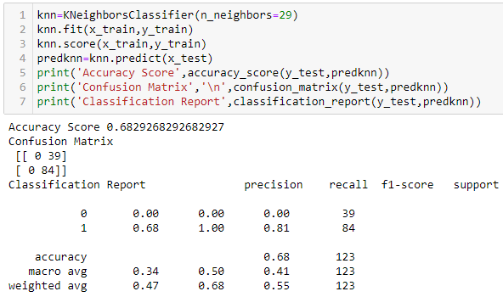
-- In the above output we see that Accuracy Report is 68% and Error is 39
Heatmap of Confusion Matrix
Output
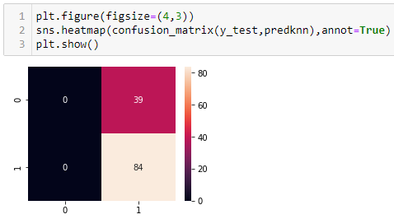

5. Random Forest Classifier
Grid Search CV
The best parameters for Random Forest Classifier is defined in the Output as shown below.
Output

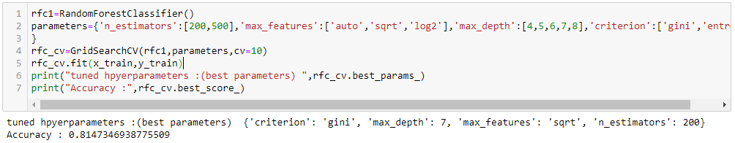
Prediction Model
In the Prediction Model we use the best parameter in the above output.
Output

-- In the above output we see that Accuracy Report is 75% and Error is 30

Heatmap of Confusion Matrix
Output

6. AdaBoost Classifier
Prediction Model
In this Prediction Model we have the output as below.
Output
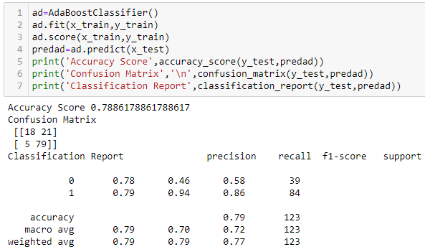
-- In the above output we see that Accuracy Report is 78% and Error is 27

Heatmap of Confusion Matrix
Output

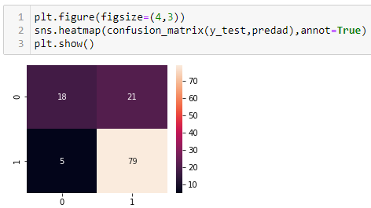

Cross Validation Score
The Cross Validation Score help us analyse which Model give us the actual accuracy based on the predictions. The least difference of Accuracy score and mean of Cross Validation Score gives us the better accuracy. In the above models Random Forest Classifier gives us the best result.

7.CONCLUDING REMARKS
Here Random Forest Classifier give the highest accuracy score. Hence we use rfc for Testing of Dataset.

